**PROJECT OVERVIEW: RELATIONAL DATABASE PROJECT(SQL)**

**TITLE: WATER AND SANITATION ACCESS IN AFRICA**

**OUTLINE**

* Introduction
* Objectives
* Data Overview
* Dataset Categories
* Data Transformation
* Business Questions
* Recommendations
* Summary
* Conclusion

1. **INTRODUCTION**

Access to clean water and proper sanitation is essential for healthy communities and sustainable development. This dataset provides key insights into water availability, functionality of water sources, sanitation infrastructure, government and NGO support, health impacts, and community satisfaction. By analyzing this data, we can identify trends, challenges, and opportunities to improve water access and sanitation across African communities, helping drive informed, data-backed solutions.

1. **OBJECTIVES**

These are the main objectives:

* To analyze data
* Identify key trends
* Provide data-driven recommendations to help governments and stakeholders improve water access and sanitation in African communities.

1. **DATA OVERVIEW (WATER ACCESSIBILITY)**

The dataset contains 2,000 records with the following relevant columns:

* Country, Region, Community Name: Identifies the location.
* Population: Number of people in the community.
* Water Availability (liters per capita per day): Measures daily water access.
* Number of Functional & Non-Functional Water Points: Indicates the status of water sources.
* Sanitation Facility Type & Annual Maintenance Cost: Details sanitation infrastructure and costs.
* Government & NGO Support: Indicates support received.
* Average Distance to Water Source (km): Measures accessibility.
* Waterborne Diseases Incidence Rate (%): Shows health impact.
* Community Satisfaction Rate (%): Indicates overall satisfaction.

1. **DATASET CATEGORIES**
2. Water Availability and Population Distribution

Examines the relationship between water resource availability and community populations.

1. Water Source Type and Functionality

Analyzes the distribution of water sources (boreholes, wells, rivers) and their operational status (functional vs. non-functional water points).

1. Sanitation Infrastructure and Maintenance

Evaluates the types of sanitation facilities (toilets vs. latrines) and their annual maintenance costs.

1. Government and NGO Support

Assesses the extent of governmental and NGO involvement in water and sanitation projects.

1. Health and Community Well-being

Investigates the correlation between water access, sanitation conditions, and waterborne disease incidence rates.

1. Community Satisfaction and Accessibility

Provides insights into community satisfaction regarding water access, sanitation quality, and proximity to water sources.

1. **DATA TRANSFORMATION**

The dataset was cleaned using **Microsoft Excel**, leveraging **Power Query** for transformation. The following steps were performed:

1. **Data Type Corrections** – Ensured that each column had the appropriate data type, making necessary adjustments where needed.
2. **Duplicate Removal** – Identified and removed duplicate records to maintain data integrity.
3. **Handling Missing Values** – Checked for missing values and addressed them accordingly to ensure completeness.
4. **BUSINESS QUESTIONS**

1. Write an SQL query to calculate the average water availability (liters per capita per day) for each country.

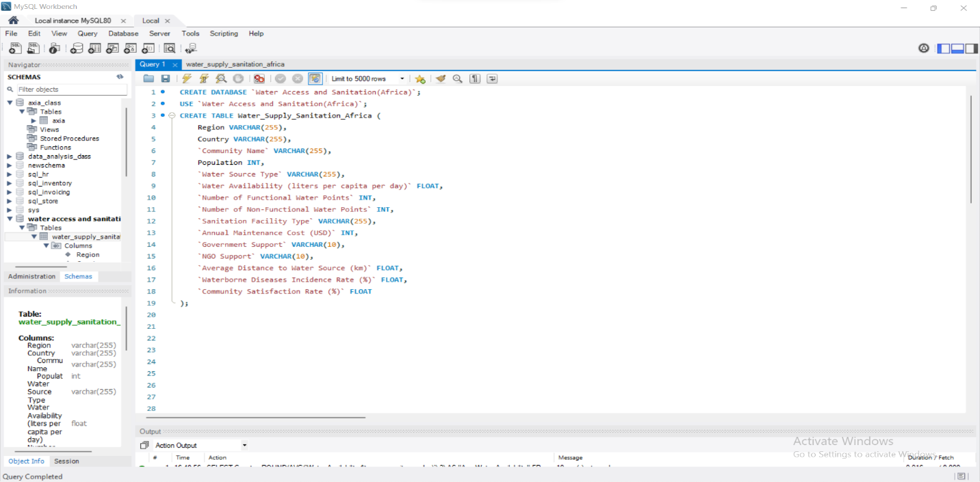

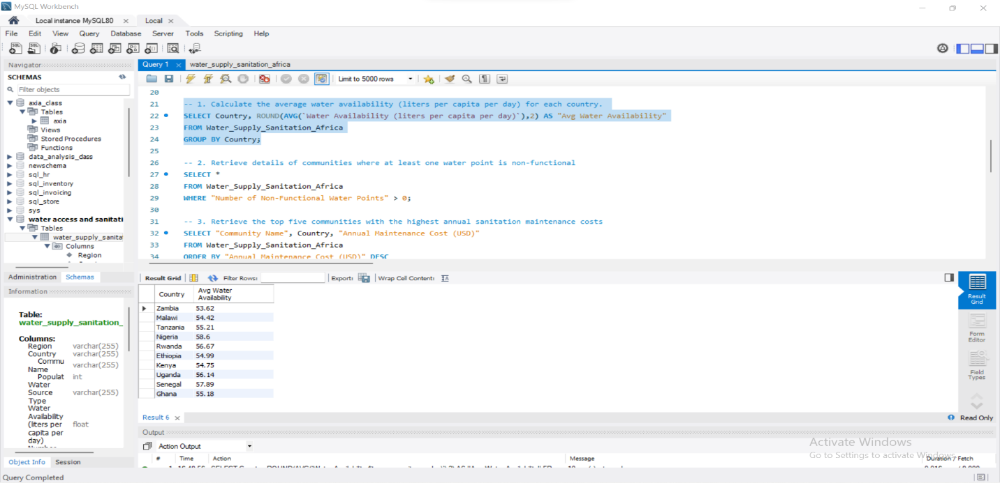

2. Write an SQL query to retrieve details of communities where at least one water point is non-functional.

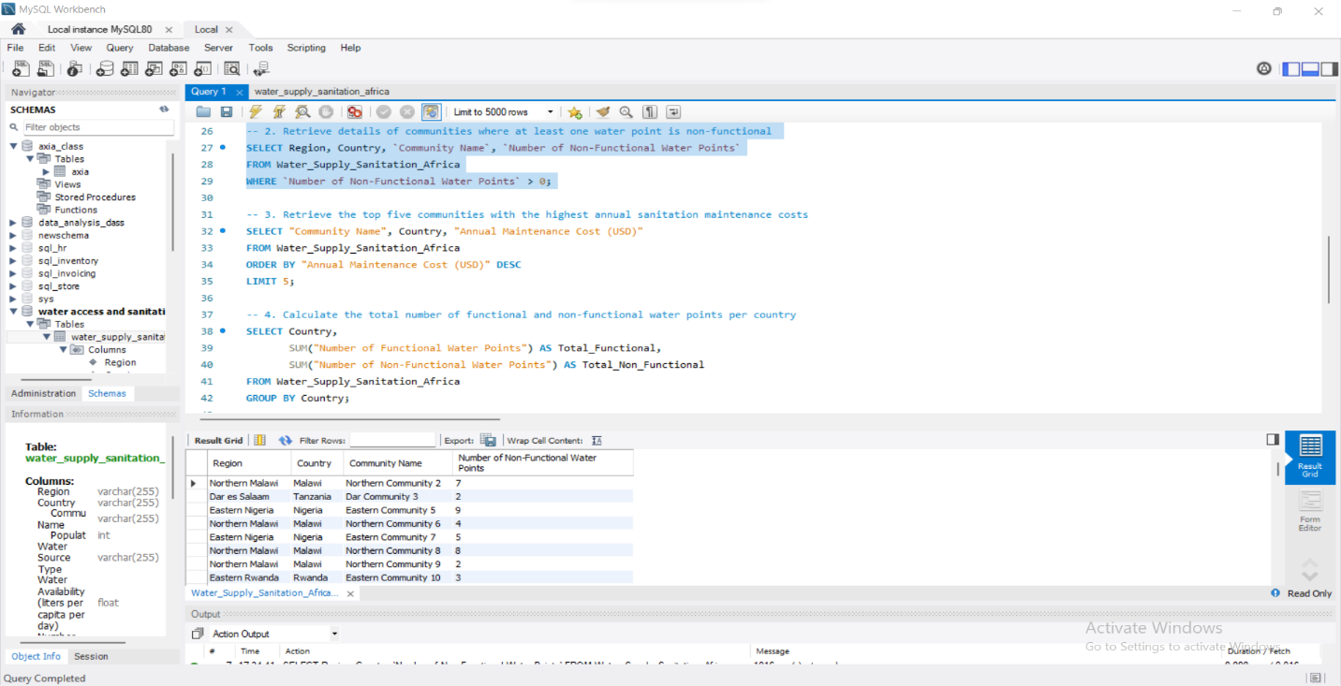

3. Please retrieve the information for the top five communities with the highest annual sanitation maintenance costs.

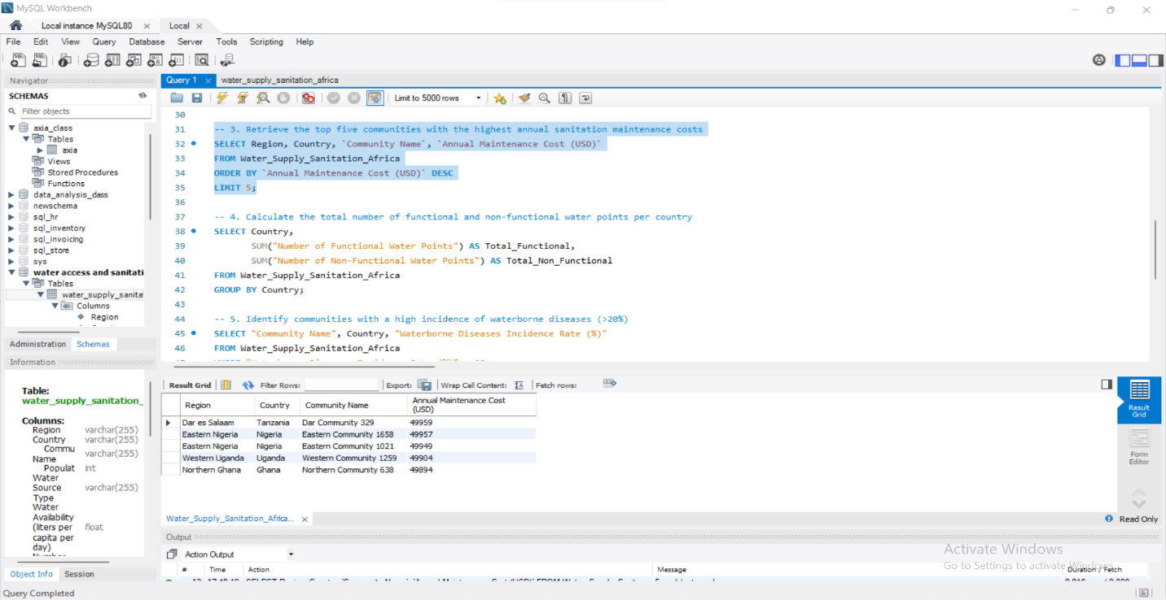

4. Calculate the total number of functional and non-functional water points per country

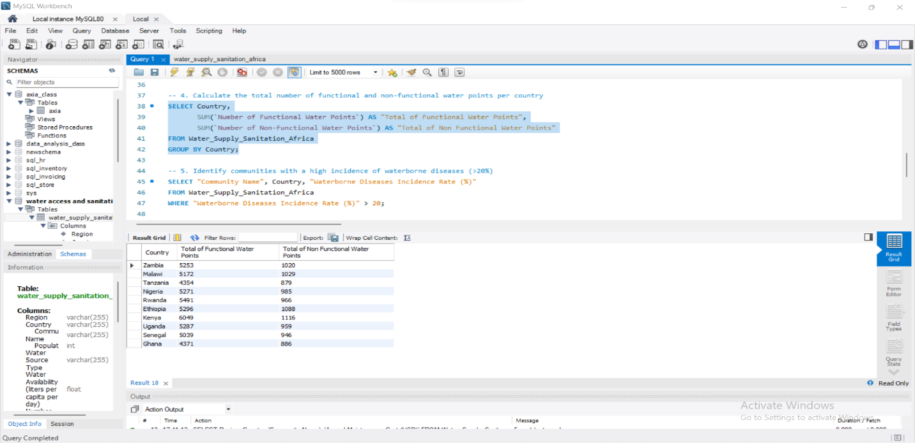

5. Identify communities with a high incidence of waterborne diseases (>20%)

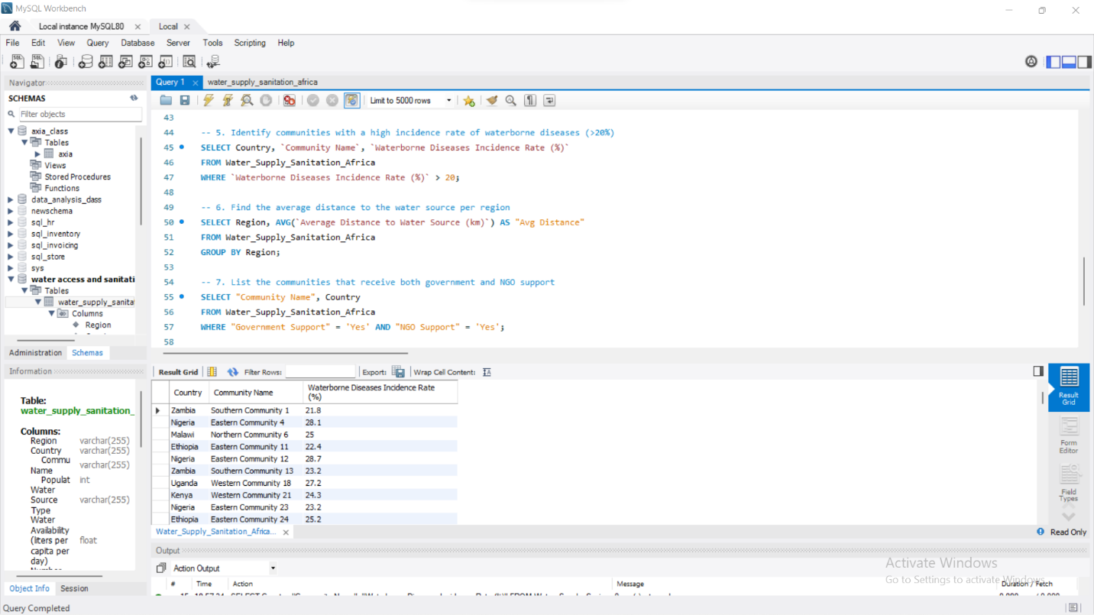

6. Find the average distance to the water source per region

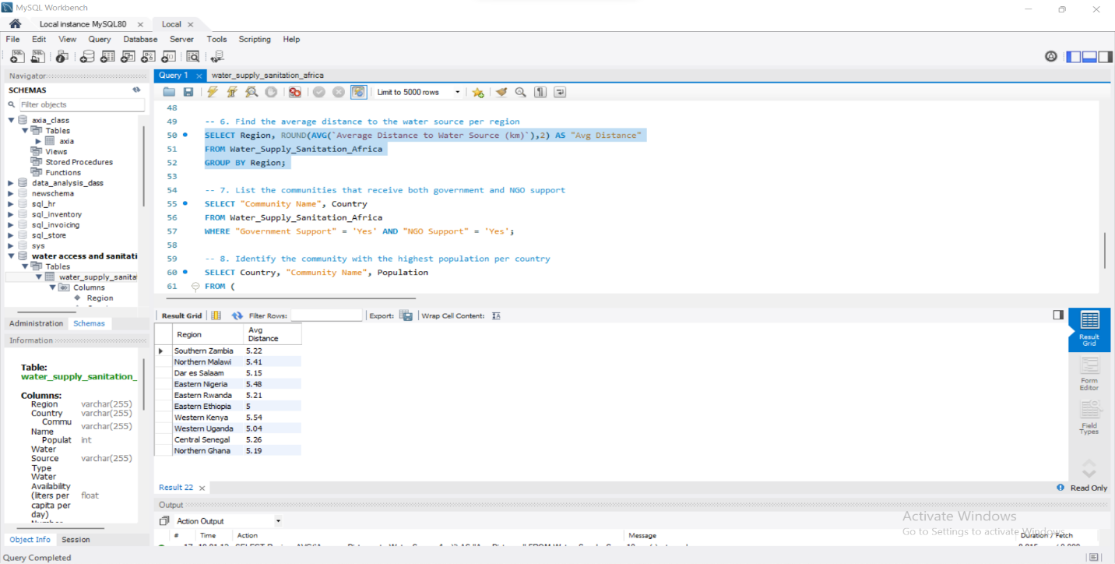

7. List the communities that receive both government and NGO support

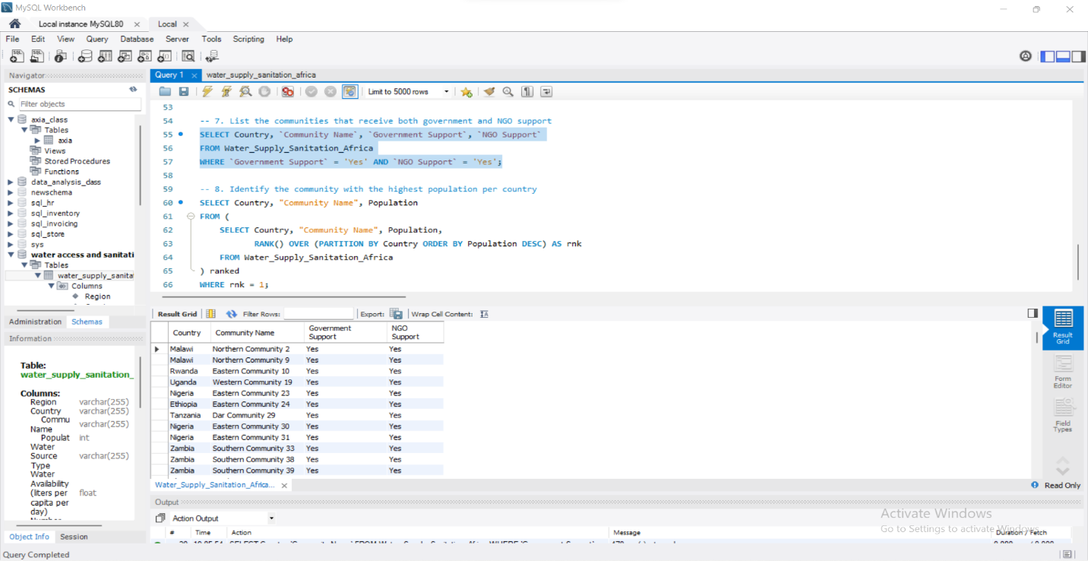

8. Identify the community with the highest population per country

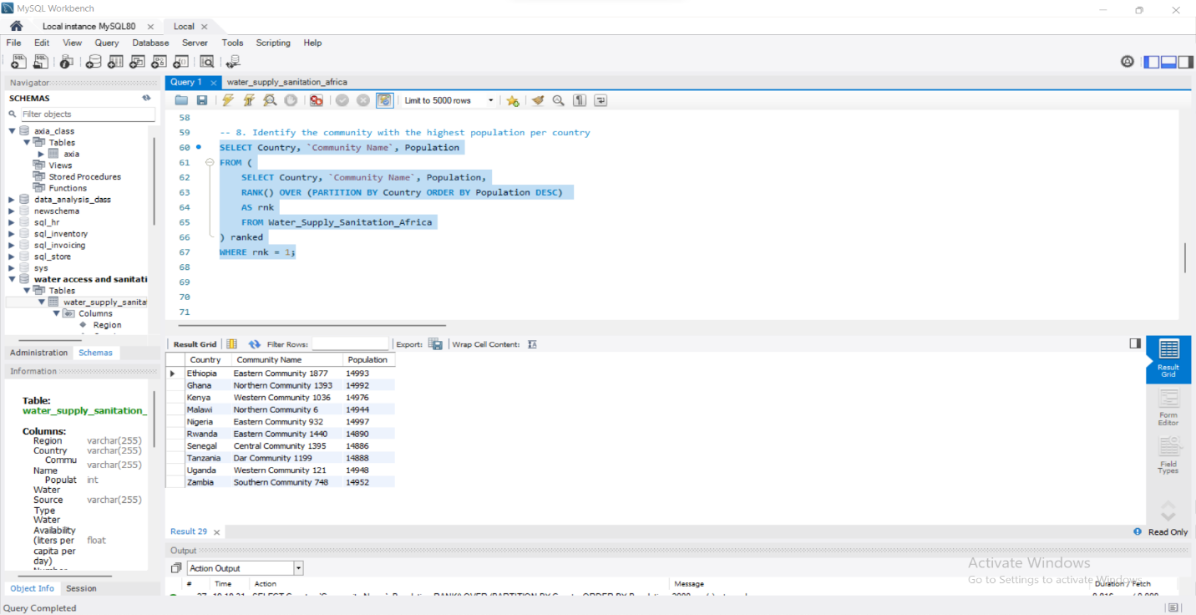

1. **RECOMMENDATIONS**
2. **Enhance Water Supply in Low-Access Areas**

Regions with low per capita water availability should be prioritized for infrastructure investments. Governments and NGOs should increase the construction of boreholes, wells, and water treatment facilities to ensure communities have sufficient daily access to clean water.

1. **Implement Regular Maintenance for Water Sources**

Many communities have non-functional water points, highlighting the need for proactive maintenance. Establishing a monitoring system and allocating resources for repairs will help sustain water infrastructure and prevent supply disruptions.

1. **Optimize Sanitation Infrastructure Spending**

High annual maintenance costs for sanitation facilities suggest the need for more cost-effective solutions. Investing in sustainable, low-maintenance sanitation technologies, such as eco-friendly toilets, can reduce long-term expenses while improving hygiene standards.

1. **Strengthen Government and NGO Collaboration**

Communities that lack both government and NGO support require urgent intervention. Strengthening partnerships between stakeholders can improve resource allocation, ensuring that underfunded areas receive the necessary infrastructure and aid.

1. **Reduce Waterborne Disease Risks Through Sanitation Improvements**

Communities with high incidences of waterborne diseases should be targeted for improved water purification systems, hygiene education programs, and proper sanitation facilities. Preventative measures such as water treatment initiatives and awareness campaigns can significantly reduce health risks.

1. **Increase Accessibility by Reducing Travel Distance**

Regions where residents travel long distances for water should be prioritized for additional water points. Strategically placing new water sources within closer proximity will ease the burden on communities and improve overall quality of life.

1. **Scale Infrastructure to Support High-Population Communities**

High-density communities require expanded water and sanitation infrastructure to meet growing demands. Allocating more resources to these areas will help prevent shortages and maintain adequate water supply and sanitation services.

1. **SUMMARY**

The analysis of water accessibility and sanitation in Africa revealed critical insights into resource distribution, infrastructure functionality, and community well-being. The data highlighted disparities in water availability across different regions, with some communities having significantly lower access to clean water. A notable number of water points were found to be non-functional, emphasizing the need for better maintenance and resource allocation. Additionally, the study showed a correlation between inadequate sanitation and higher incidences of waterborne diseases, reinforcing the importance of improved hygiene facilities. Government and NGO support varied across locations, directly impacting community satisfaction and overall health conditions. Through structured SQL queries, key trends and problem areas were identified, providing a basis for targeted interventions.

1. **CONCLUSION**

The findings of this project underscore the urgent need for improved water management strategies in African communities. While some regions benefit from adequate water and sanitation infrastructure, many still struggle with accessibility and maintenance issues. Addressing these gaps requires coordinated efforts from governments, NGOs, and local communities to enhance water source functionality, sanitation facilities, and overall public health. By leveraging data-driven approaches, policymakers can implement more effective and sustainable solutions to ensure equitable water access for all.

[Water Accessibility SQL File](Water%20Supply%20Africa.sql)